EXP:4 STOCK MAINTAINANCE SYSTEM

1.USE CASE DIAGRAM:
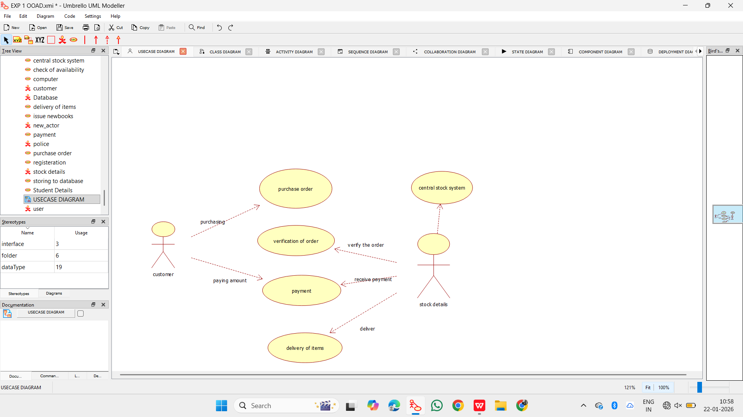

2.CLASS DIAGRAM:
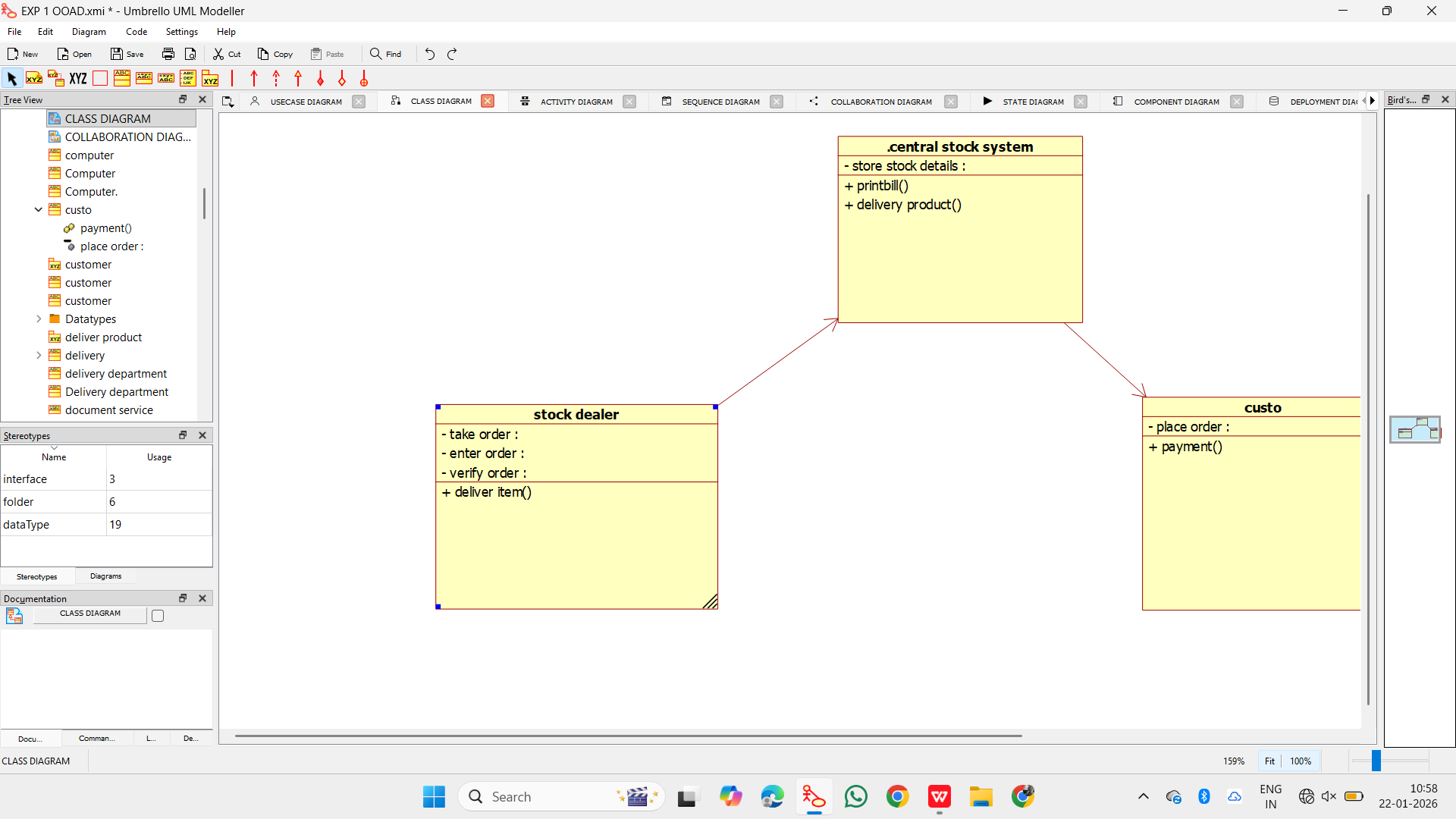

3.ACTIVITY DIAGRAM:
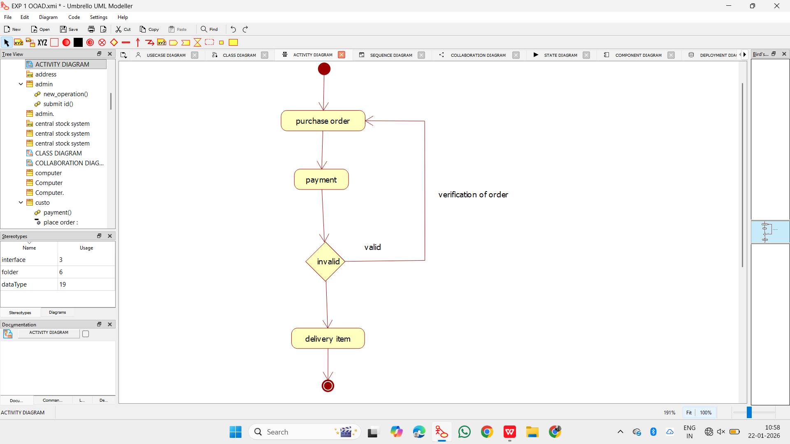

4.SEQUENCE DIAGRAM:
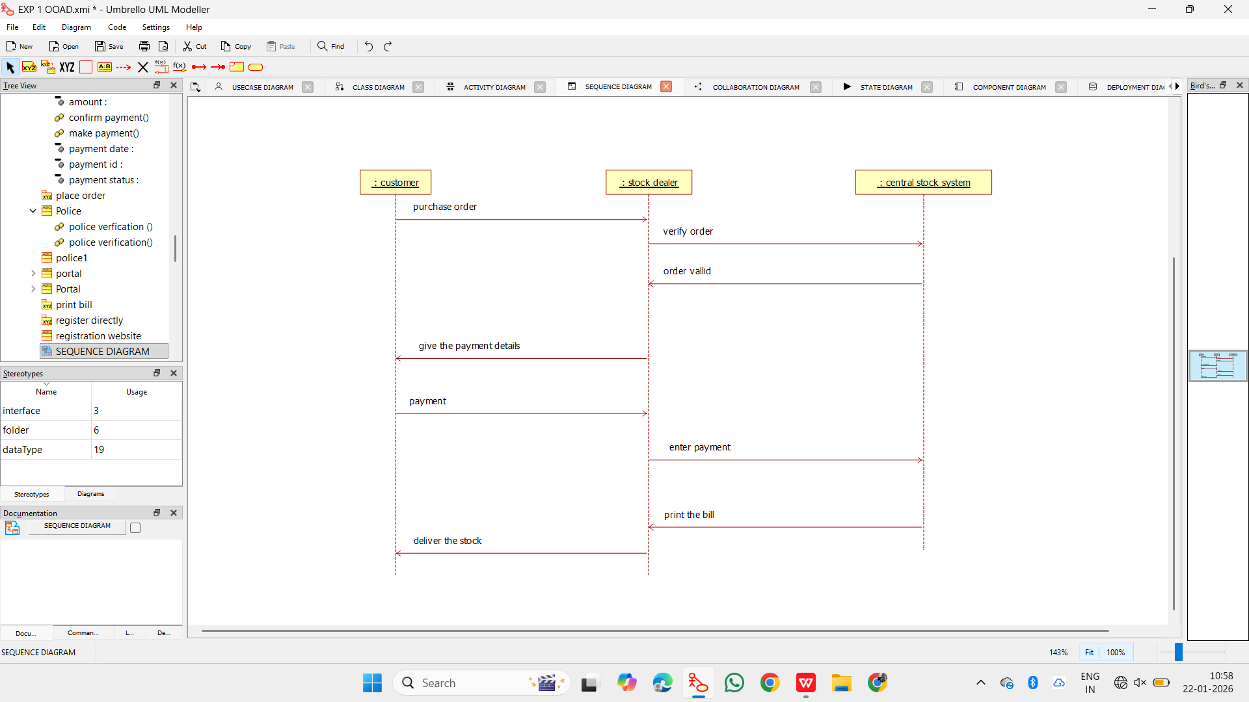

5.COLLABORATION DIAGRAM:
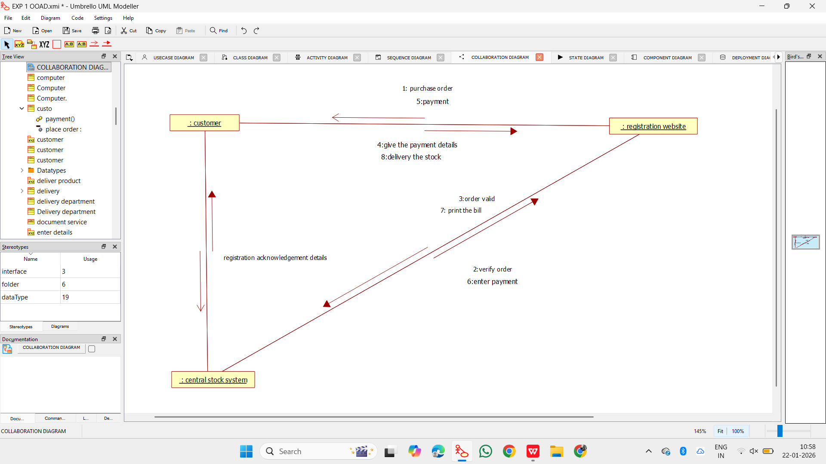

6.STATE DIAGRAM:
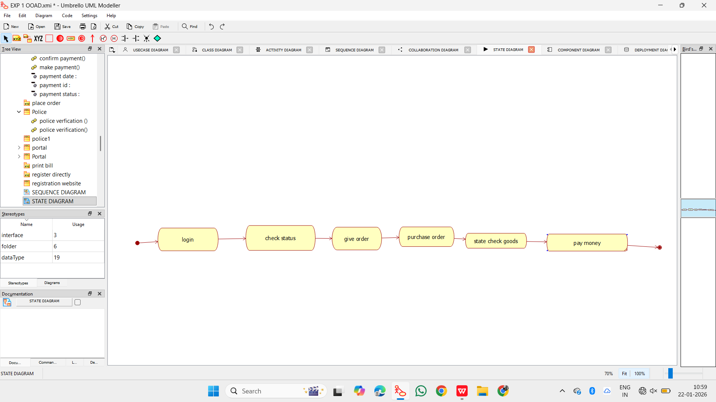

7.COMPONENT DIAGRAM:
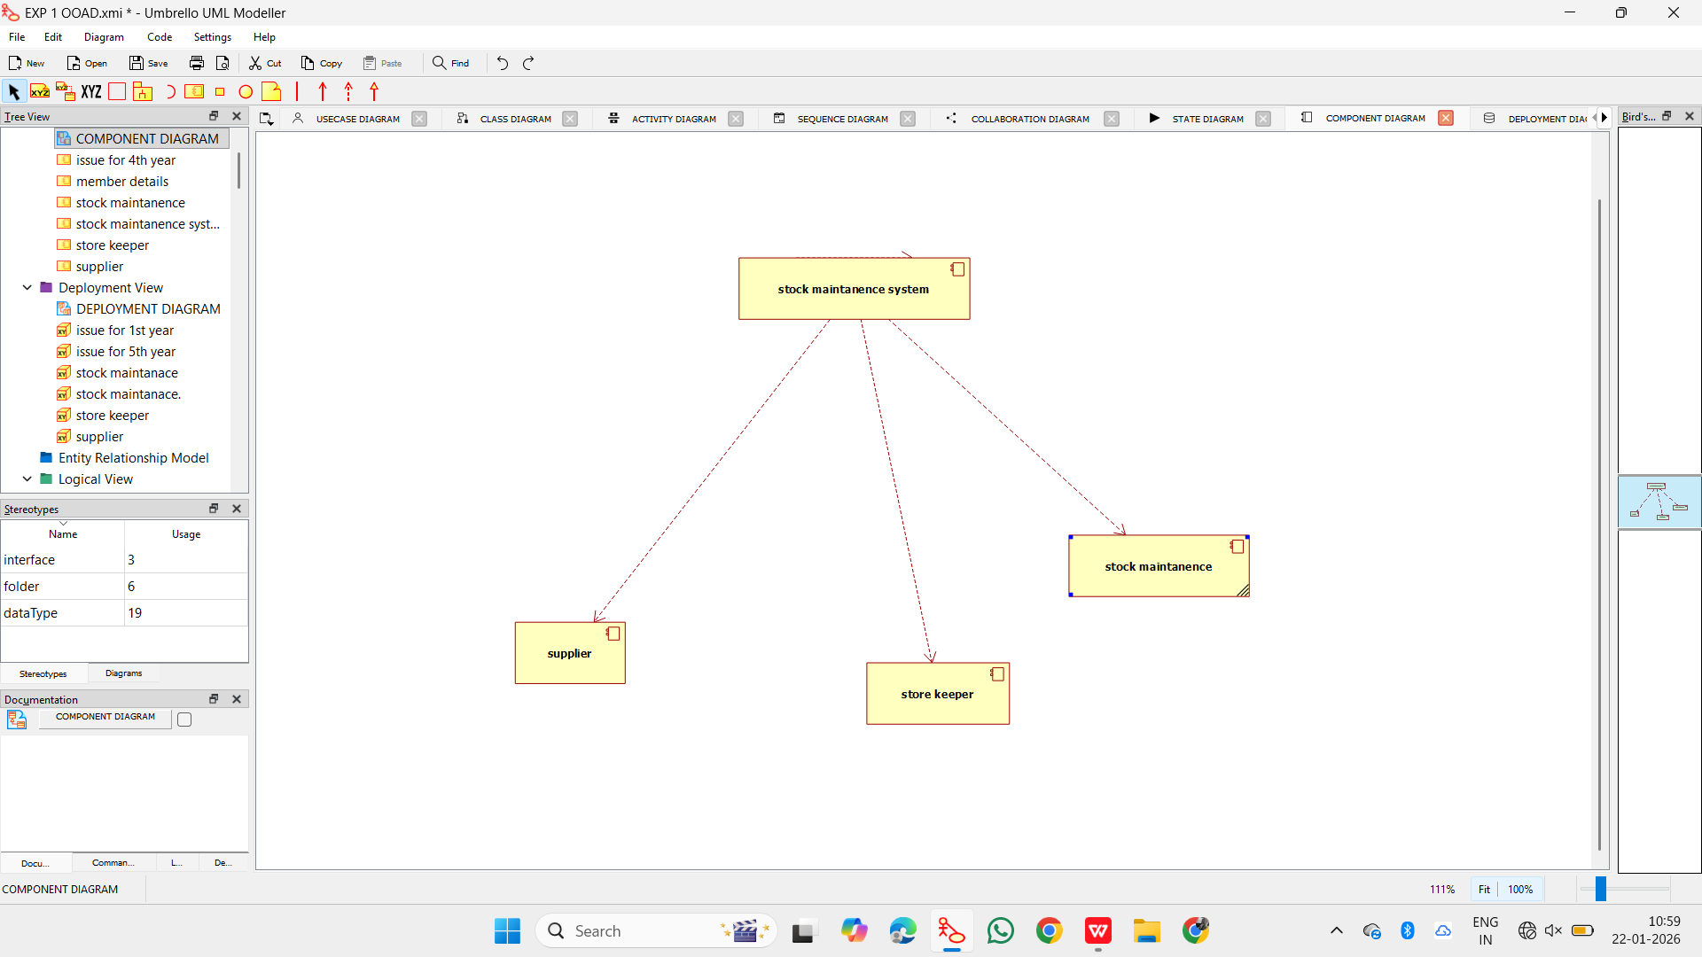

8.DEPLOYMENT DIAGRAM:

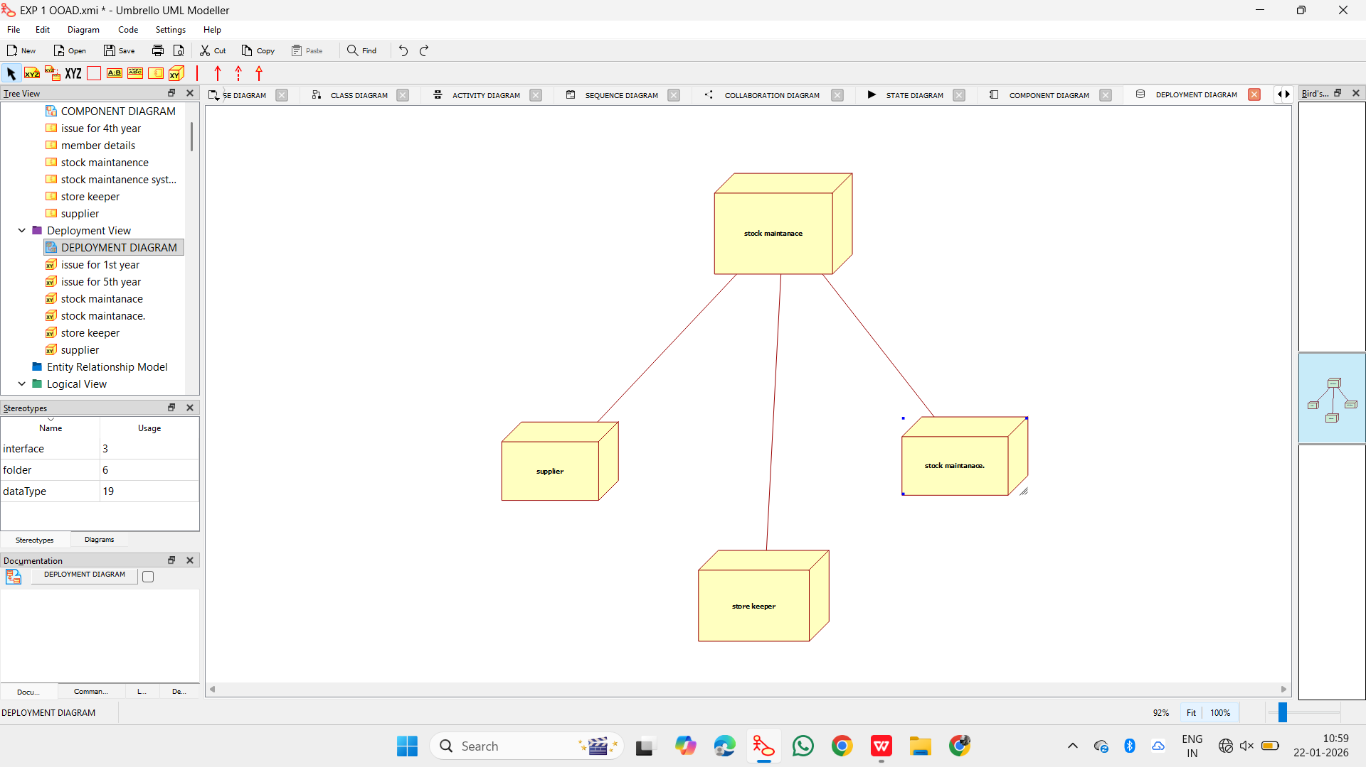

9.PACKAGE DIAGRAM:
